[ Beginner & Low Kyu Guidance (1) ]

As mentioned before, Beginner and Low Kyu refer to players who are:

**Beginner – below 15 kyu**

**Low Kyu – 6~14 kyu**

Generally those are players who just started in Go, and who are quite likely to make much progress within days. **Beginners** may still have a hard time with the rules of this game, and it sometimes happens they don’t know when a game ends. As for **Low Kyu** players, they could beat beginners easily but got crushed by players who are just a little stronger than them, and might face constant losses. Therefore, the strategy that applies to those two groups are different.

In my opinion the **keywords** and **suggestions** for those two groups are:

|  |  |  |
| --- | --- | --- |
|  | **Keywords** | **Suggestions** |
| **Beginner** | Rules  Liberty | OGS Bot Games  Play on 9x9  Kill stones |
| **Low Kyu** | Skill Training  Territory & Efficiency | Play on bigger boards  Traditional Openings  Tsumego Training  Play slow games online |

**Tips for Beginners**

Perhaps you have just decided to learn about this game after the news of AlphaGo, or maybe you simply want a glimpse of this mysterious game because the AI project you’re currently working on requires some background knowledge. You might also be a kid who is curious about the game --- Whoever you are, you’ve come to the right place. Here are tutorials about how to go through the very first stage of **Beginner.**

**Keyword 1: Rules**

Go is a game, and a game has rules. Therefore, the very first thing a beginner should do is to remember the rules. Unfortunately, the rules of Go is a bit complicated, which scares away beginners. My job here is to brief you on the most important rules so that you can finish a game properly; and if you want more information on Go rules, just turn to Wikipedia.

The explanations of Go terms are available at Sensei’s library: <https://senseis.xmp.net/> .

The formal Go rules can be divided into three parts: before game, during game and after game.

**1.1 Before Game – Nigiri & Bow & Time Setting**

The term *Nigiri* refers to the process to decide which player should play as black. Normally it’s done by guessing the stones. Here are the steps:

(1) One player (usually the elder one, or the one with the white stones) grabs some stones out of the white box, and holds them.

(2) The other player needs to make a guess about whether the total number of the stones is odd or even. If your guess is odd, just put one black stone on the board. If your guess is even, put two black stones on the board.

(3) The first player puts all the white stones on the board and see if the guess is correct.

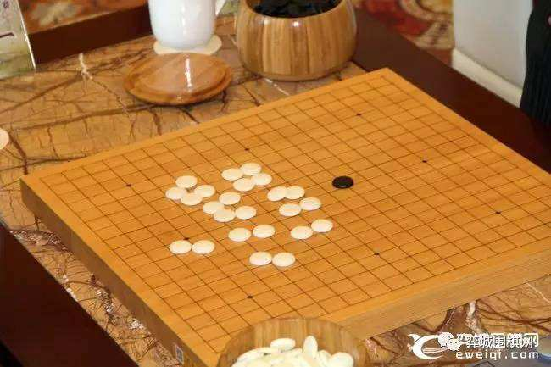

**Figure 1.** *Nigiri* – guessing the stones. On this board the guess is odd but the total is even, so the elder one plays as black, or can choose the side to play as.

Usually, if your guess is correct, you play as black, or you play as white. But there are also tournaments where a correct guess grants you the right to pick whichever side you’d like to play. Such rules of tournaments should be announced before the game starts; and players should pay attention to them.

In an online game, normally the Nigiri part is done by programs. You just need to click “Automatic” as the color you will play as. You can also decide your color. You also need a proper **time setting** that is acceptable by both players. A game invitation needs to be confirmed by two opponents to start.

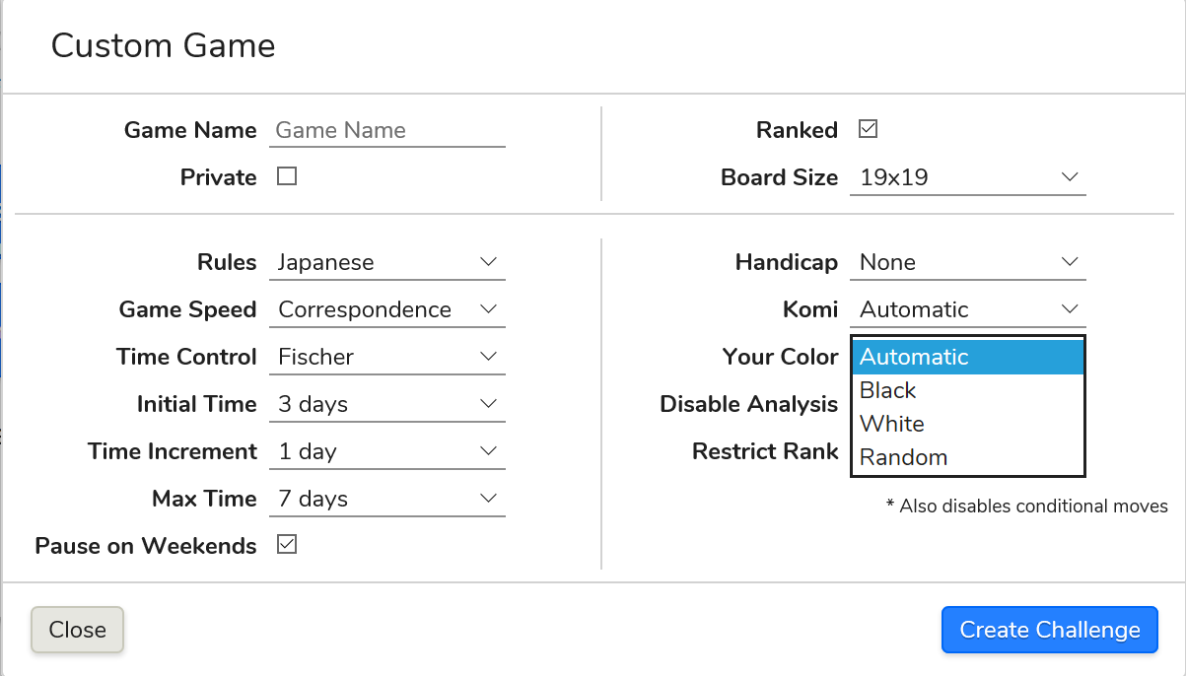

**Figure 2.** Game invitation online. Here we choose OGS as an example. On the left are rules and **time settings**; and on the right you can choose your color as Automatic, Black, White or Random. Automatic and Random all initiate the Nigiri process.

Black gets to play the first move, and usually is the boss of early game. So to make the game fair, black has to make up to white at the end of the game, and the compensation is called *komi*. We will discuss about *komi* later in After Game.

After *Nigiri*, the game is ready to start. But before it starts, please remember that it is normal etiquette to **take a bow** towards your opponent, to be polite. Keep in mind that the result of games does not matter; what matters is good manners.

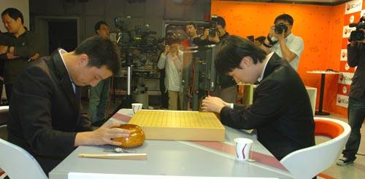

**Figure 3.** Take A Bow Before Game Starts.

**1.2 In Game – *Liberty* & *Ko* situation & when to end a game**

*Ko* is the most complicated situation in this game, but it is easy to explain. All rules – Chinese & Japanese & Korean or any rule in the world – ban the situation when the same board appears again in one game. Let’s take a look at this 9x9 board.

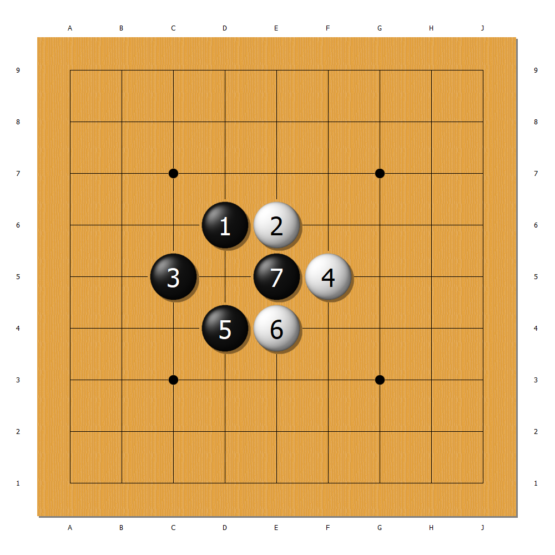

**Figure 4.** A Ko Situation. The number on the stones refers to the order in which moves are made, and this is a universal way to keep game records.

Now the black stone 7 has only one *liberty* and can be removed by white with one move at D5. (As liberty decides whether a stone can survive and is especially essential to beginners, it is illustrated in Keyword 2. If you have no idea what *liberty* means, please refer to that part before going on.)

So white now makes the D5 move and removes that black stone:

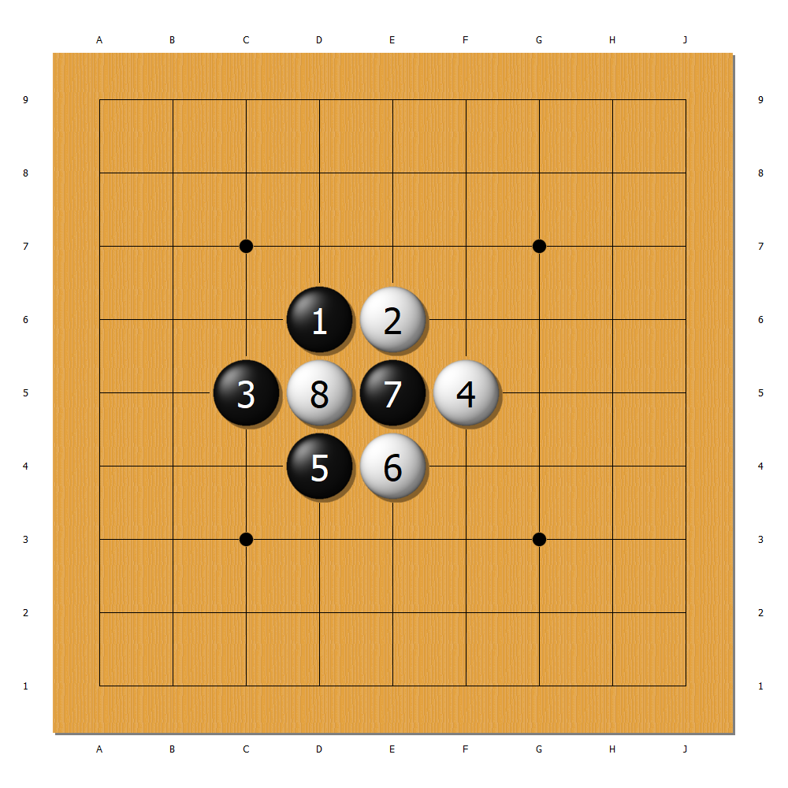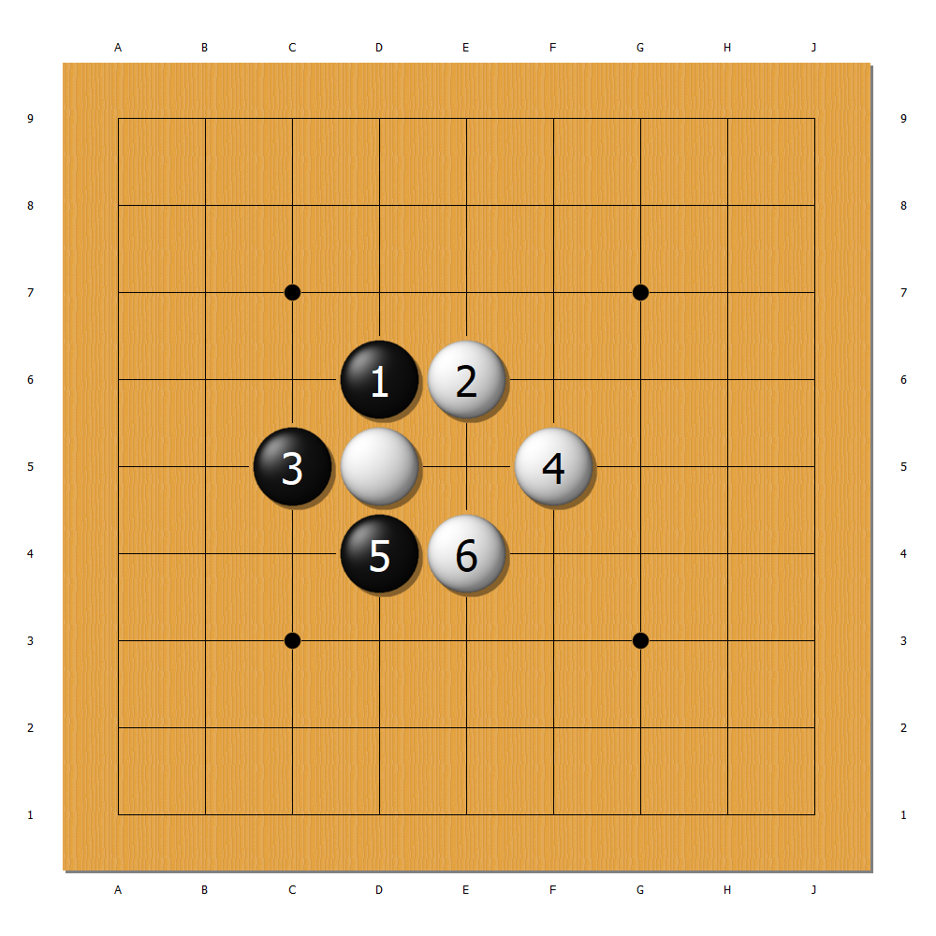

**Figure 5.** White removes the stone.

Now the new move 8 is also at risk: just like the previous move 7, it also has only one liberty and can be removed. But what happens if black makes the E5 move right away?

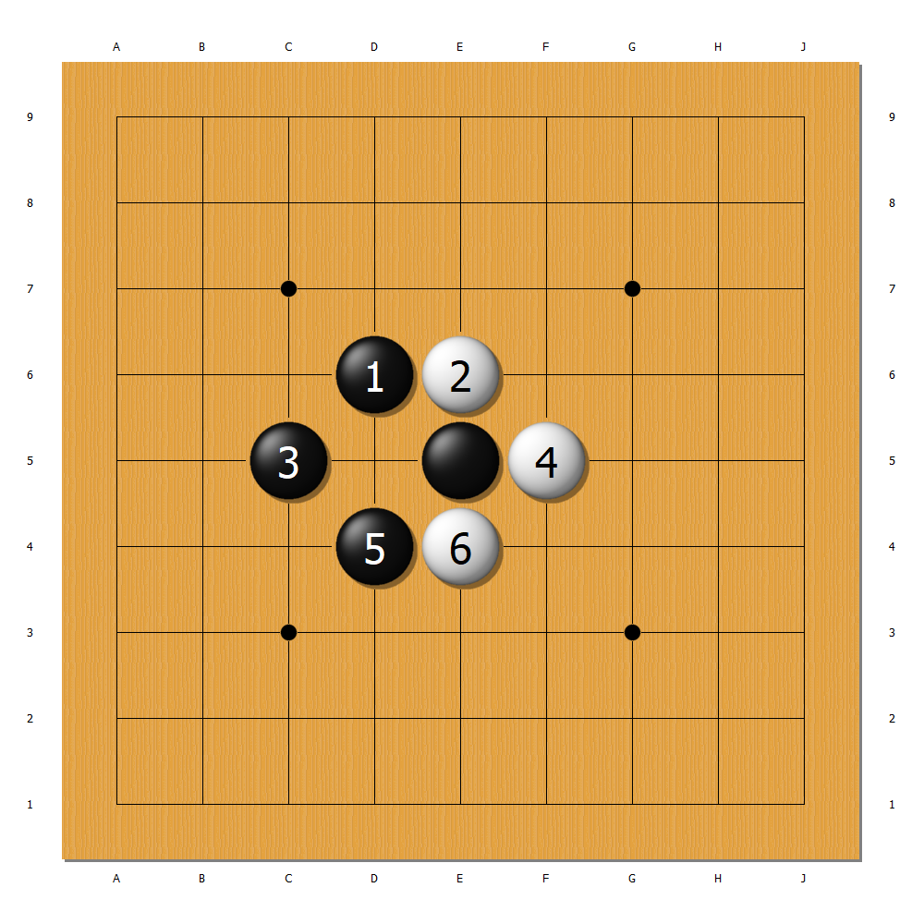

**Figure 6.** Comparison between the original board (left) and the board after black makes the E5 move (right).

**1.3 After Game – *Score counting rules***